**Lessons Learned from Aviation Occurrence: Integrated Pilots’ Visual Parameters into Cockpit Recorders for Accident Investigation and Prevention**

**\*Thomas Wang1 Wen-Chin Li2 and John J. H. Lin3**

Authors’ Biographies

***1*** *Thomas Wang is currently the Managing Director of Aviation Safety Council, Taiwan. He has been a group chairman, investigator-in-charge, or accredited representative in over 30 occurrence investigations in Taiwan and abroad. He is the investigator-in-charge of the February 4, 2015 ATR72 accident. Thomas is a former airline pilot on the Airbus A300.Contact E-mail:* [*wang@asc.gov.tw*](mailto:wang@asc.gov.tw)

***2*** *Dr. Wen-Chin Li is a Senior Lecturer in the Safety and Accident Investigation Centre, Cranfield University, United Kingdom. He is a Chartered Ergonomist and Human Factors Specialist of the Institute of Ergonomics and Human Factors, and an Aviation Human Factors Specialist of European Association of Aviation Psychology (EAAP). His expertise includes Accident Investigation, Visual Attention and Situation Awareness, and Flight Deck Design. Contact E-mail:* [*wenchin.li@cranfield.ac.uk*](mailto:wenchin.li@cranfield.ac.uk)

***3*** *Dr. Jr-Hung Lin is a postdoctoral researcher at the office of institutional research at National Central University, Taiwan. His research interests focus on developing eye-movement application, integrated eye tracking technology with other devices, and eye-tracking programming. Contact E-mail:* [*john.jrhunglin@gmail.com*](mailto:john.jrhunglin@gmail.com)

**Abstract**

On 4th February 2015 an ATR 72-600 (GE-235) was on a scheduled domestic flight from Taipei to Kinmen Island, Taiwan. The aircraft experienced a loss of control during initial climb and crashed into the Keelung River after take-off from Taipei Songshan Airport. Four of the five crew members and 39 of 53 passengers were killed. As the investigation into the accident progressed, it was found that the flight crew had shut down the wrong engine. This became a crucially important factor for the investigators who were attempting to understand why the pilot flying misidentified the problem and shut down the wrong engine, and why the error was not detected and corrected by the other crewmembers. The limited information and parameters recorded in the FDR and CVR make it impossible to recreate or demonstrate pilots’ attention distributions and situation awareness and, most importantly, what led the pilots select this action. This significantly increased the challenge of forming a reasonable hypothesis to conduct further scientific trials for the final sector of the flight. The purposes of this research are to address the limitations of current accident investigation, due in part to the disparity between the recorded parameters of FDR and the lack of a recording of the pilot’s visual parameters to reflect to the associated flight parameters. The authors propose developing a cockpit visual tracking technology that is integrated with cockpit recorders, as a solution that will not only assist accident investigations, but also benefit pilot training, facilitate human-centered flight deck design and, crucially, prevent accidents through a more effective analysis of near miss and accident events.

**Keywords:** Accident Investigation, Attention Distribution, Human-Computer Interaction, Situation Awareness, Visual Scan Pattern

1. **Introduction**

On 4th February 2015 an ATR 72-600 (GE235) was on a scheduled domestic flight from Taipei to Kinmen Island, Taiwan. The aircraft experienced a loss of control during initial climb and crashed into the Keelung River after take-off from Taipei Songshan Airport. Shortly after take-off, the aircraft's number 2 (right-hand) engine propeller experienced an uncommanded auto-feather - an action not initiated by the flight crew. Within approximately 5 seconds, the pilot flying (PF) started to retard power of the operative engine number 1 (left-hand) shutting it down completely in the moments before the aircraft's wing impacted a bridge and the aircraft came to rest in the Keelung River. Four of the five crew members, including both pilots and 39 of 53 passengers were killed (figure 1). A key challenge to the accident investigators was to understand why the pilot flying misidentified the problem and shut down the wrong engine, and why the error was not detected and corrected by the other crewmembers. Due to the limited information and parameters recorded on the Flight Data Recorder (FDR) and the Cockpit Voice Recorder (CVR), it was not possible analyze the pilots’ attention distributions and situation awareness that is inextricably linked with the aircraft and flight parameters. Recreating the actions of the crew - based on how their attention distribution was influenced by the airplane's parameters and other cues and feedback - would have enabled the investigators to gain an understanding of the impact of these factors on the crew's situational awareness.

In accidents such as this, the availability of a tool to record pilots’ visual scan patterns, would provide a powerful evidence base to facilitate scientific analysis of accident investigation. Since pilots’ visual behavior plays a central role in cognitive processing, understanding when and where pilots distribute their attentions is critical to both situation awareness and safe operations (Li, Yu, Braithwaite, & Greaves, 2015). Visual tracking technology has been proven, through empirical research, to have a significant contribution to advanced flight deck design and training in aviation for decades (Ellis & Liston, 2016; Wu, Wanyan, & Zhuang, 2015). A number of visual parameters can be precisely recorded and analyzed by eye-tracking devices. Parameters that can be recorded include: a pilots’ percentage of fixation in specific areas of instruments, which are defined as area of interest (AOIs), is closely associated with attention distribution; pilots’ fixation duration measuring how long they sustain attention on an AOI to diagnose an abnormal situation; saccade amplitude can be used to evaluate the extent to which pilots shifted attention among instruments for gaining situation awareness; and pupil size is used to assess pilots’ workload. Identifying scan pattern of eye movement is crucial for accident investigation in assessing the cognitive processes related to Human–Computer Interaction (HCI) (Honn, Satterfield, McCauley, Caldwell, & Dongen, 2016; Kearney, Li, & Lin, 2016; Yu, Wang, Li, & Braithwaite, 2014).

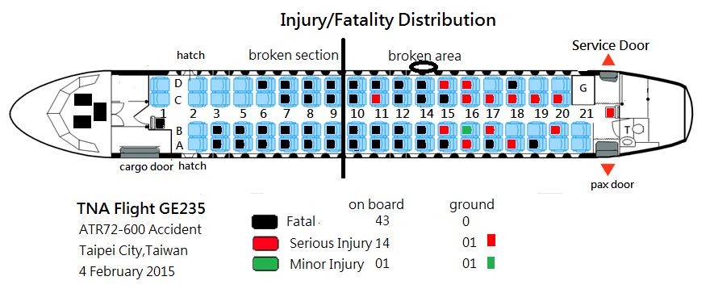

Figure 1. GE235 injury and fatality distributions

1. **Background of the Flight GE235**

The occurrence flight GE235 was on a regular public transport service from Songshan to Kinmen. Captain A, who was the pilot-in-command (PIC), occupied the left seat and was the pilot flying (PF) for the take-off, while Captain B occupied the right seat and was the pilot monitoring (PM). One first officer occupied the cockpit jump seat as an observer pilot (OBS). According to the FDR and CVR data, GE235 took off from Songshan runway 10 at 1051 -the take-off roll commenced at 1051:39. Four seconds later (1051:43), the PM mentioned that the automatic take-off power control system (ATPCS)[1] was not armed. The PF decided to continue the take-off roll. Seven seconds later, the PM stated “*oh there it is ATPCS armed*”, and the aircraft became airborne at 1052:01. The crew selected an altitude of 5,000 feet and airspeed of 115 knots on the autopilot. At 1052:34 the Songshan tower controller instructed the GE235 flight crew to contact Taipei Approach while the aircraft was commencing a right turn and climbing through an altitude of 1,000 feet.

As the aircraft was continuing the right turn and climbing through 1,200 feet, the FDR indicated that engine number 1 (ENG 1) was operating in an uptrim condition with its bleed valve closed. That corresponded with the beginning of an ATPCS sequence, which included the auto-feathering of the engine number 2 (ENG 2) propellers. The Master Warning (MW) annunciated in the cockpit and the ENG 2 propeller pitch angles started to advance to the feather position accompanied by the indication of the “ENG 2 FLAME OUT AT TAKE OFF” procedure on the Engine Warning Display (EWD).

At 1052:41, the autopilot was disconnected as the aircraft climbed through an altitude of 1,300 feet. Three seconds later, the ATPCS sequence ended and the ENG 2 propeller was fully feathered. At 1052:43 the PF stated “*I will pull back engine one throttle*”. The PM responded “*wait a second cross check*”, but the ENG 1 Power Lever Angle (PLA) had already been retarded from 75 degrees to 66 degrees.

At 1053:00, the PM stated “*okay engine flame out check*”. The PF responded “*check”* and the PM stated “*check up trim yes, auto feather yes*”. At 1053:05 the PF responded “*okay*”. At almost the same time, the PM was recorded as saying “*watch the speed*” because the indicated airspeed had reduced to 101 knots. The PF then announced ”*pull back number one*”, and the ENG 1 PLA was retarded to 49 degrees. While the ENG 1 power lever was retarded, the PM said “*okay now number two engine flameout confirmed*”, and the PF responded “*okay*” but the ENG 1 PLA still remained at 49 degrees.

At 1053:09, the aircraft had climbed to 1,630 feet, which was the highest altitude recorded for the occurrence flight. The indicated airspeed was 102 knots. The automatic flight control system Indicated Air Speed (IAS) mode then reverted into PITCH HOLD[2] mode and one second later the stall warning annunciated in the cockpit for one second. The PF then stated “*terrain ahead*” and the PM replied “*okay lower…*”. At 1053:13 the stall warning sounded again for four seconds and the stick shakers activated. The PM stated “*okay push, push back*”, to which the PF stated “*shut*”. The PM responded “*wait a second…throttle throttle*”.

Between 1053:13 and 1053:15, the ENG 2 PLA was advanced to 86 degrees and the ENG 1 PLA was retarded to around 34.5 degrees (idle position). At 1053:18, the aircraft was heading 087 degrees but in a continuous left turn with a 10 to 20 degree angle of bank, descending through 1,526 feet at airspeed of 101 knots.

At 1053:19 the PF said “*number one*” followed by “*feather shut off*”. The PM called *“number feather*”, and then the stick shakers and stick pushers activated several times until 1053:27. At 1053:24, the FDR indicated that the ENG 1 condition lever was in the fuel shut off position, and six seconds later the ENG 1 propeller had attained the feathered position. The aircraft’s indicated airspeed was 110 knots at an altitude of 1,165 feet and descending.

At 1053:35, the PM declared an emergency (Mayday) to Air Traffic Control (ATC). The aircraft was heading 050 degrees and had commenced a bank to the right. From 1053:46 to 1054:04, the flight crew tried to engage the autopilot twice, but did not succeed. At 1053:53, the OBS said “*how come it becomes like this*”. At 1054:05, the PM stated “*both sides…lost*” and two seconds later the PM realized and stated “*no, engine flameout, we lost both sides*”. At 1054:09, the PF stated “*restart the engine*”, when the altitude was 545 feet and 105 knots.

At 1054:20, the ENG 1 condition lever was moved out of the shut off position and at 1054:25, the ENG 1 high pressure speed (NH1) increased to 30%. The aircraft’s altitude and IAS at that time were 400 feet and 106 knots respectively. The aircraft also started to bank to the left. At 1054:27, the PF said “*wow pulled back the wrong side throttle*”. From that time on, the aircraft entered an aerodynamic stall from which it did not recover.

At 1054:34, the enhanced ground proximity warning system (EGPWS) “pull-up” warning was annunciated in the cockpit. At 1054:35 the aircraft’s left bank angle increased from 10 to 80 degrees. The aircraft’s left wing then collided with a taxi driving on the overpass. The wing then impacted the fence and a light pole at the edge of the overpass located southwest of the Keelung River occurrence site. The aircraft continued to bank to the left after those collisions and then entered the river inverted (see Figure 2).

Figure 2. GE235 key events rendered on a fused satellite image and digital surface model

1. **Challenges to the Investigation**

The occurrence was the result of many contributing factors which culminated in a stall-induced loss of control. During the initial climb after takeoff, an automatic takeoff power control system (ATPCS) sequence was triggered which resulted in the uncommanded auto-feather of ENG 2 propellers. Following the uncommanded auto-feather, the flight crew did not perform the documented abnormal and emergency procedures to identify the failure and implement the required corrective actions. This led the PF to retard power of the operative ENG 1 and ultimately shut it down. The loss of thrust during the initial climb and inappropriate flight control inputs by the PF generated a series of stall warnings, including activation of the stick shaker and pusher. The crew did not respond to the stall warnings in a timely and effective manner. The aircraft stalled and continued descent during the attempted engine restart. The remaining altitude and time to impact were not enough to successfully restart the engine and recover the aircraft.

After 16 months of investigation, the final report was published in June 2016. There are a total of 25 findings and 16 safety recommendations issued to the related organizations. Despite the completion of the investigation, there were still some questions/challenges that been raised during the investigation that the investigation team could not answer or explain. Based on the available evidences, the occurrence investigation report identified WHAT had happened – the pilot flying shut down the operative ENG 1.causing a total loss of power and the aircraft subsequently crashed. However, the investigation team was unable to conclude why the pilot flying insisted on retarding the power of ENG 1 and ultimately shut it down, while the pilot monitoring had already identified the engine problem as being with ENG 2. Nor the investigation team was able to conclude why the pilot monitoring did not discover the pilot flying’s actions of retarding ENG 1 and moving the lever to the fuel shut off position.

In this instance, the pilots of GE235 not only had to distribute their visual attention among displays for cross-check to maintain safe flight operations, but also had to resolve unexpected malfunctions - such as ATPCS not armed and feathering of ENG 2 - under time pressure. To effectively analyze this event, it is essential to understand the effects of the additional workload on both pilots during the critical phase of take-off. The crew's ability to scan the instrument panels - monitoring tasks - and manage other flight operations tasks during the take-off and climb was impacted by the numerous Crew Resource Management (CRM) issues related to communication, attention distribution and situation awareness. Based on the FDR and CVR, the PM noted ENG 2 feathering and pointed this out on the Engine Warning Display (EWD) a number of times throughout the event. The PF, however, continued to retard and shut down ENG 1. Though the PF and PM had numerous interactions during flight, the lack of effective communication was a considered a key factor in this event. The FDR provided evidence of what actions the pilots performed within the scope and limitations of the recorded parameters, while the CVR enabled the investigators to analyze the call-outs, commands and other voice communications. This evidence was limited however and could not provide an insight that could help to explain what exactly they did and why they did it? To gain a better understanding of this and other such events, it would be helpful to understand: what elements acted the triggers to an accident? How the pilots processed the information present on the EWD? What information the PF and PM saw during their cross-check and scans? The investigation team considered a number of scenarios during the accident investigation in order to understand and explain the pilot's behavior and its impact on the final outcome. Had the team been able to apply methods that included human information processing theory (HIP), attention allocation, workload distribution, and working memory, it may have been possible to understand and explain the pilot’s actions/reactions and the rationale for these actions. The investigation cannot however make conclusions solely based on theories and hypothesis. Without evidence of the link between the crews’ actions and the aircraft's flight parameters, the occurrence investigation report was published without the explanation of WHY.

1. **Lessons Learned from Investigating Human Information Processing**

The draft final report of the occurrence investigation was sent to relevant organizations and authorities for comments following its completion, in accordance with the regulations. Several comments from the Taiwan Civil Aeronautics Administration (CAA) were related to the analysis of the occurrence flight crew performance. The CAA suggested that the investigation team conduct further analysis to “*increase the possibility to clarify what the flight crew can see and perceive in the cockpit*” during the final moments of the occurrence flight. The CAA also suggested several revisions to the conclusions of the draft final report, and requested explanations to speculate why the occurrence flight crew had made those mistakes. The Council, after reviewing these comments, in the absence of supporting evidence, did not accept the comments (though the comments were appended for inclusion in the final report). There is growing recognition of the need to collect eye movement data which can help to explain pilots’ cognitive processes related to attention, situation awareness and decision-making in response to what pilots saw and perceived in the flight deck. The importance and utility of this data mode for accident investigation and prevention (Kowler, 2011; Wu et al., 2015; Yu et al., 2014) is becoming increasingly obvious.

* 1. **Eye Movement Patterns Reflecting Cognitive Process**

Analysis of accident investigations indicates that 75% of aviation accidents involved poor perceptual encoding on the flight deck (Jones & Endsley, 1996). Numerous studies have been carried out to investigate the ability of pilots to monitor the status of the automation (flight mode) using the flight mode annunciator (FMA) (Björklund, Alfredson, & Dekker, 2006). One such experiment by Björklund et al. (2006) revealed that with 40% of pilots not able to verify the mode changes for monitoring task in the flight deck, that pilots were, in fact, quite poor at monitoring flight modes (figure 3). The movements of a person's eyes offer the prospect to explore the relationship between attention distributions and task performance. Understanding the function of selective attention - which includes attention for perception, conscious awareness and action - is the key to understanding how and why pilots act and interact with the aircraft systems and with each other. Pilot’s visual attention is necessary for perception (an important part of the cycle for gaining and retaining situational awareness), which in turn helps to prevent information overload, and enables the crew to focus on the appropriate action based on incoming information (R. J. Mumaw, N. B. Sarter, & C. D. Wickens, 2001). Eye scan pattern is one of the most powerful methods for assessing human beings’ cognitive processes in Human–Computer Interaction (Ahlstrom & Friedman-Berg, 2006).

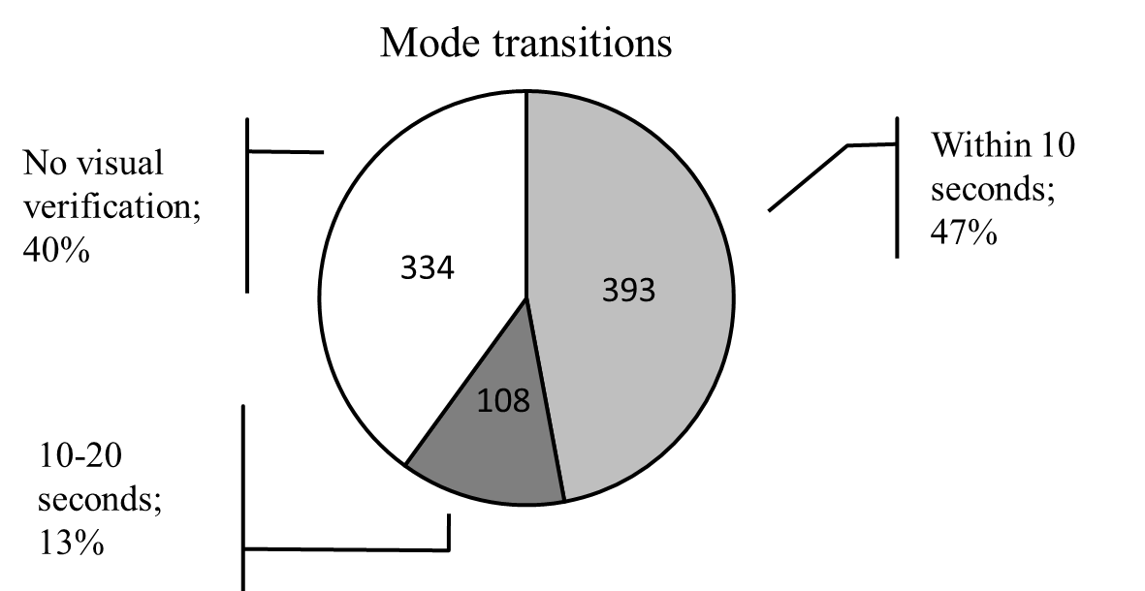

Figure 3: Monitoring mode transitions by Björklund et al. (2006)

The GE235 occurrence investigation report revealed that the PF’s decision to disconnect the autopilot shortly after the first Master Warning had increased his workload, reduced his visual capacity to assess and process the critical information present on EWD, and ultimately leading to him mistakenly shutting down the operative engine. If it were possible to collect the GE235 pilots’ fixations data among cockpit displays, it may have been possible to explain what these pilots could see and perceived and how this related to his decision to disconnect the autopilot and retard the power of ENG 1, despite the fact that it was ENG 2's propellers that had an uncommanded auto-feather. Studying visual activity provides an objective approach for assessing the cognitive processes related to attention distribution, information processing, situation awareness and real-time decision-making (Ayaz et al., 2010). Eye movements are closely linked with visual attention and can be analysed to explore how much effort and shifting attention occurred whilst performing visual tasks (Kowler, 2011). Previous studies indicate that a person’s fixations are not attracted by salient objects, but rather the meaningful information for the task being undertaken (Henderson, 2003). Fixation duration comes from deliberate consideration and induces more fixation points for acquiring more detailed information (Schulte-Mecklenbeck, Kuhberger, & Ranyard, 2011).

* 1. **Perceived Workload Impacts Visual Behaviors and Situation Awareness**

During the uncommand auto-feather of GE235 ENG 2, the flight condition recorded by the FDR and the voice conversations recorded on the CVR implies that the workload on the flight deck increased exponentially beyond the pilot's capabilities, and this which is likely to have been a significant contributing factors that eventually led to the PF's confusion and his mistakenly shut down the (operative) ENG 1. The CAA had suggested a human performance issue related to workload and situation awareness needed to conduct further research and training for accident prevention (Aviation Safety Council, 2016).

Aircraft automation has been cited a source of confusion leading to errors during operation, and difficulty in training (FAA Advisory Circular (AC) 25-11B, 2014), and “mode management” difficulties with aircraft automation in fact have been well documented in numerous incidents and accidents. Kilingaru, Tweedale, Thatcher, and Jain (2013) found that humans have a very specific way of distributing visual attention depending on the current workload. There were three categories of attention distribution including: (1) attention focusing - where continuous fixations on a particular instrument within a limited time period, are clustered to identify the instrument being interrogated; (2) attention blurring - where visual behavior is characterized by small number of fixations and increased number of transitions between instruments; and (3) misplaced attention - where very short fixation spans inside the instrument panel and more time is spent fixating outside each of instrument regions on the instrument panel rather than fixating on the relevant instruments. Furthermore, saccade defined as rapid eye movement between fixations - generally declines as a function of increased mental workload, and the pupil diameter increases as a function of cognitive demand (Ahlstrom & Friedman-Berg, 2006). Saccadic eye movements are controlled by top-down visual processes, which are coordinated closely with perceptual attention (Zhao, Gersch, Schnitzer, Dosher, & Kowler, 2012). This indicates that saccadic paths are intentional and meaningful, and are based on the requirements of the task and trajectory prediction in the near future (Kowler, 2011). The path of saccades is associated with selective attention and accurate judgments for perceptual targets (Henderson, 2003).

In general, eye tracking research has found blink rate and blink duration declines as a function of increased workload (Van Orden, Jung, & Makeig, 2000; Zeghal, Grimaud, Hoffman, & Rognin, 2002). Research has also found pupil dilation increases as a function of cognitive processing demands (Iqbal, Adamczyk, Zheng, & Bailey, 2005; Iqbal, Zheng, & Bailey, 2004). Furthermore, increases in workload have also been found to increase the number of saccades, decrease saccade duration (Rognin, Grimaud, Hoffman, & Zeghal, 2004; Zeghal et al., 2002), and increase the frequency of long fixations (Van Orden, 2000; Van Orden et al., 2000), lessening situation awareness (Kearney et al., 2016). A potential benefit of applying eye tracking technology as an indicator of cognitive workload is that it provides for the possibility of capturing fluctuations in workload that occur over short time intervals (Ahlstrom & Friedman-Berg, 2006). Visual behaviours has been proven as a precursor to initiating the cognitive process related to perceived workload, attention distribution, situation awareness, and problem-solving (Lavine, Sibert, Gokturk, & Dickens, 2002).

* 1. **Applying Eye Tracking Technology for Training and Investigation**

Monitoring Flight Mode Annunciator (FMA) and calling out the mode transitions are thought to be important for obtaining and keeping situation awareness on automation systems on the flight deck. Previous research (Hüttig, Anders, & Tautz, 1999; R. J. Mumaw, N. Sarter, & C. D. Wickens, 2001) demonstrated that pilots actually do not look at the FMA very often (the percentage of fixation time is typically less than 5%), which could mean that the pilots do not value the information displayed on the FMA (Hüttig et al., 1999). Although pilots are supposed to visually monitor the FMA, they are not given directives on how this should be done. In addition to monitoring tasks, most airlines training programs have established procedures for double-checking mode transitions, such as pilot flying and pilot monitoring cross check procedures related to critical events. The reason for these cross checks is to compensate for imperfect coordination and monitoring by an individual crew member. Double-checking is supposed to occur by verbally announcing the intended action (making a call-out) to make it visually noticed by the pilot monitoring, thereby directing the attention of the pilot flying to the status and behavior of the automation. As evidenced in numerous accident reports, this type of procedure is not always followed and, in fact, in some accidents (e.g. GE235 accident) call-outs quickly get pushed aside by other more pressing tasks during time pressure and high workload situations. Pilots report that this is especially true in higher workload situations which, ironically, are the situations in which accurate mode awareness can be critical (Björklund et al., 2006).

The GE235 accident was the result of many contributing factors which culminated in a stall-induced loss of control. During the initial climb where ENG 1 uptrim and ENG 2 auto-feathered, the pilots did not perform the abnormal and emergency procedures to identify the failure and implement the required corrective actions. This led the PF to retard power of operative ENG 1 and ultimately shut it down, even though PM was continuously stating ENG 2 flameout confirmed. There were numerous interactions and cross-check between both pilots based on the procedure present to the EWD from 75 degree of Power Lever Angle (PLA) to shut down the ENG 1. However, there is a lack of evidence to determine the PF’s visual attention as the PM stated ‘*okay now number two engine flameout confirmed*’, and, equally, the PM’s visual attention while the PF announced ‘*pull back number one*’. Why did the PF perform an action that was contradictory to the information stated by the PM - whose situation awareness of ENG 1 uptrim and ENG 2 auto-feather was actually correct? Why did the PM not perceive and correct the PF’s mistakes? What were both the PF and the PM seeing in the lead-up to the accident? How do pilots process information perceived in their environment and how does an adverse event affect that perception? By applying eye tracking technology in the flight deck, the above questions regarding pilots’ attention distribution, situation awareness and cognitive information processing can be examined more accurately during adverse events (see figure 4a & 4b). The utility of this data is enormous, and the potential for reducing the likelihood of a situation escalating towards an accident is a positive effect of understanding these processes.

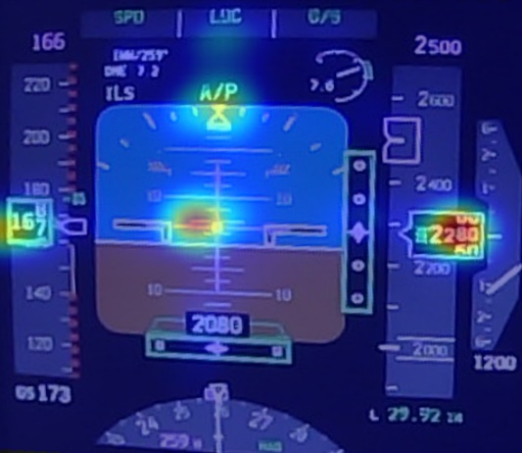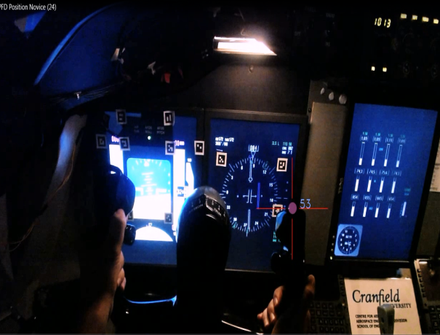

4a 4b

Figure (4a) “Heat map” shows pilot’s visual attention shifts among Attitude, Altitude, Heading and Airspeed among PFD; (4b) pilot’s attention shift among PFD, ND, MCP and EICAS

1. **Conclusion**

With over 75% of pilot errors caused by perceptual failures deck (Jones & Endsley, 1996), the application of eye-tracking in the aviation domain has been offered as a possible solution as it provides direct feedback of visual attention, which could help to diagnose factors that could impact upon pilots’ attention and situation awareness on the flight deck (Robinski & Stein, 2013). The study of visual information processing - in the form of eye movements can provide an insight into how pilots perceive information and how the acquisition of that perception can feed their situational awareness. By applying eye tracking device to evaluate the relation between human operators and interface design, that eye movement, including gaze, fixation and saccade, is controlled by ongoing cognitive processing, so that it is possible to analyze human cognitive processes by examining eye movements parameters. This assumption has been validated by many previous researchers in reading and cognitive tasks (Ahlstrom & Friedman-Berg, 2006; Salvucci & Goldberg, 2000), information processing tasks (Rayner, 1998), scanning behavior (Allsop & Gray, 2014), interface evaluation (Goldberg & Kotval, 1999), and Human Computer Interaction (Yu et al., 2014). In order to maintain safe operations, GE235 pilots should have followed the instructions on EWD, identified the relevant checklists for the current situation, and then acted accordingly. Both the PF and the PM encountered consecutive activation of Master Warning which induced an extremely high workload that impaired their situation awareness that, in turn, led to a break down in communications amongst the crew (a contributing factors of GE235 accident). The accident investigators, however, could not collect enough hard evidence and could not, therefore, ascertain why the PF continued to retard ENG 1 while the PM stated ‘*number two engine flameout confirmed*’. Were eye tracking technology installed on the flight deck, it may have been possible to record evidence related to pilots’ eye movement patterns. By examining the visual characteristics of crews on flight decks, it might facilitate training to improve pilots’ cognitive processes and speed up pilots’ reaction time should they encounter an adverse situation. It might be a long off before the industry applies the integration of eye tracking technology into the flight deck, but the importance of gaining an understanding of the processes associated with the human's understanding of and interaction with the aircraft and its flight parameters cannot be understated.

**References**

Ahlstrom, U., & Friedman-Berg, F. J. (2006). Using eye movement activity as a correlate of cognitive workload. *International Journal of Industrial Ergonomics, 36*(7), 623-636. doi:10.1016/j.ergon.2006.04.002

Allsop, J., & Gray, R. (2014). Flying under pressure: Effects of anxiety on attention and gaze behavior in aviation. *Journal of Applied Research in Memory and Cognition, 3*(2), 63-71. doi:10.1016/j.jarmac.2014.04.010

Aviation Safety Council. (2016). *Aviation Occurrence Report (Report No. ASC-AOR-16-06-001)*. Taipei, Taiwan Retrieved from <https://www.asc.gov.tw/upload/acd_att/ASC-AOR-16-06-001%20CH.pdf>.

Ayaz, H., Willems, B., Bunce, S., Shewokis, P. A., Izzetoglu, K., Hah, S., . . . Onaral, B. (2010). Cognitive workload assessment of air traffic controllers using optical brain imaging sensors. *Advances in understanding human performance: Neuroergonomics, human factors design, and special populations*, 21-31. doi:10.1201/EBK1439835012-c3

Björklund, C. M., Alfredson, J., & Dekker, S. W. (2006). Mode monitoring and call-outs: An eye-tracking study of two-crew automated flight deck operations. *The International Journal of Aviation Psychology, 16*(3), 263-275.

Ellis, S. R., & Liston, D. B. (2016). Visual features used by airport tower controllers: Some implications for the design of remote or virtual towers. In N. Furstenau (Ed.), *Virtual and Remote Control Tower: Research, Design, Development and Validation* (pp. 21-51). Springer Nature, Switzerland: Furstenau, N.

FAA Advisory Circular (AC) 25-11B. (2014). *Electronic Flight Deck Displays*. Retrieved from <http://www.faa.gov/documentLibrary/media/Advisory_Circular/AC_25-11B.pdf>.

Goldberg, J. H., & Kotval, X. P. (1999). Computer interface evaluation using eye movements: methods and constructs. *International Journal of Industrial Ergonomics, 24*(6), 631-645.

Hüttig, G., Anders, G., & Tautz, A. (1999). *Mode awareness in a modern glass cockpit.* Paper presented at the The 10th International Symposium on Aviation Psychology, Dayton.

Henderson, J. M. (2003). Human gaze control during real-world scene perception. *Trends in Cognitive Sciences, 7*(11), 498-504. doi:10.1016/j.tics.2003.09.006

Honn, K. A., Satterfield, B. C., McCauley, P., Caldwell, J. L., & Dongen, H. P. A. (2016). Fatiguing effect of multiple take-offs and landings in regional airline operations. *Accident Analysis and Prevention, 86*, 199-208. doi:10.1016/j.aap.2015.10.005

Iqbal, S. T., Adamczyk, P. D., Zheng, X. S., & Bailey, B. P. (2005). Towards an index of opportunity: understanding changes in mental workload during task execution *Proceedings of the SIGCHI Conference on Human Factors in Computing Systems* (pp. 311-320). New York, NY: ACM.

Iqbal, S. T., Zheng, X. S., & Bailey, B. P. (2004). Task-evoked pupillary response to mental workload in human-computer interaction *CHI'04 extended abstracts on Human factors in computing systems* (pp. 1477-1480). New York, NY: ACM.

Jones, D. G., & Endsley, M. R. (1996). Sources of situation awareness errors in aviation. *Aviation Space and Environmental Medicine, 67*(6), 507-512.

Kearney, P., Li, W. C., & Lin, J. J. H. (2016). The impact of alerting design on air traffic controllers' response to conflict detection and resolution. *International Journal of Industrial Ergonomics, 56*, 51-58. doi:10.1016/j.ergon.2016.09.002

Kilingaru, K., Tweedale, J. W., Thatcher, S., & Jain, L. C. (2013). Monitoring pilot “situation awareness”. *Journal of Intelligent & Fuzzy Systems, 24*(3), 457-466. doi:10.3233/IFS-2012-0566

Kowler, E. (2011). Eye movements: The past 25 years. *Vision Research, 51*(13), 1457-1483. doi:10.1016/j.visres.2010.12.014

Lavine, R. A., Sibert, J. L., Gokturk, M., & Dickens, B. (2002). Eye-tracking measures and human performance in a vigilance task. *Aviation Space and Environmental Medicine, 73*(4), 367-372.

Li, W. C., Yu, C. S., Braithwaite, G., & Greaves, M. (2015) Interface design and pilot attention distribution whilst pursuing a dynamic target. *Vol. 9174. Lecture Notes in Computer Science (including subseries Lecture Notes in Artificial Intelligence and Lecture Notes in Bioinformatics)* (pp. 408-415).

Mumaw, R. J., Sarter, N., & Wickens, C. D. (2001). *Analysis of pilots’ monitoring and performance on an automated flight deck.* Paper presented at the The 11th International Symposium on Aviation Psychology, Columbus, OH.

Mumaw, R. J., Sarter, N. B., & Wickens, C. D. (2001). *Analysis of pilots’ monitoring and performance on an automated flight deck.* Paper presented at the 11th International Symposium on Aviation Psychology, Columbus, OH.

Rayner, K. (1998). Eye movements in reading and information processing: 20 years of research. *Psychological bulletin, 124*(3), 372.

Robinski, M., & Stein, M. (2013). Tracking visual scanning techniques in training simulation for helicopter landing. *Journal of Eye Movement Research, 6*(2).

Rognin, L., Grimaud, I., Hoffman, E., & Zeghal, K. (2004). *Assessing the impact of a new instruction on air traffic controller monitoring tasks.* Paper presented at the Proceedings of the International Conference on Human–Computer Interaction in Aeronautics, Toulouse, France.

Salvucci, D. D., & Goldberg, J. H. (2000). *Identifying fixations and saccades in eye-tracking protocols.* Paper presented at the Proceedings of the 2000 symposium on Eye tracking research & applications, Palm Beach Gardens, Florida, USA.

Schulte-Mecklenbeck, M., Kuhberger, A., & Ranyard, R. (2011). The role of process data in the development and testing of process models of judgment and decision making. *Judgment and Decision Making, 6*(8), 733-739.

Van Orden, K. F. (2000). Real-time workload assessment and management strategies for command and control watchstations: Preliminary ﬁndings. *Proceedings of the Human Factors and Ergonomics Society Annual Meeting.* Retrieved from <http://www.dtic.mil/matris/sbir/sbir011/Navy89b.doc>

Van Orden, K. F., Jung, T. P., & Makeig, S. (2000). Combined eye activity measures accurately estimate changes in sustained visual task performance. *Biological Psychology, 52*(3), 221-240. doi:10.1016/s0301-0511(99)00043-5

Wu, X., Wanyan, X., & Zhuang, D. (2015). Pilot's visual attention allocation modeling under fatigue. *Technology and Health Care, 23*, S373-S381. doi:10.3233/THC-150974

Yu, C.-s., Wang, E. M.-y., Li, W.-C., & Braithwaite, G. (2014). Pilots’ visual scan patterns and situation awareness in flight operations. *Aviation, space, and environmental medicine, 85*(7), 708-714.

Zeghal, K., Grimaud, I., Hoffman, E., & Rognin, L. (2002). Delegation of spacing tasks from controllers to flight crew. Impact of controller monitoring tasks *Proceedings of the IEEE/AIAA Digital Avionics Systems Conference, 2B3* (pp. 1-9). Irvine, CA: IEEE Press.

Zhao, M., Gersch, T. M., Schnitzer, B. S., Dosher, B. A., & Kowler, E. (2012). Eye movements and attention: The role of pre-saccadic shifts of attention in perception, memory and the control of saccades. *Vision Research, 74*, 40-60. doi:10.1016/j.visres.2012.06.017

1. The ATPCS is designed to automatically feather the propeller during takeoff and approach if the engine torque decreased below 18.5 percent rated torque. The system also provided for relaying a 'power uptrim' (engine power increase) signal to the operating engine.
2. According to ATR72 IAS take off sub-mode internal logic, when the airplane has no sufficient energy to maintain the selected indicate airspeed (IAS) and continue climbing with a minimum ascending slope, the IAS mode automatically disengages and reverts to PITCH HOLD mode.